# **CprE 381: Computer Organization and Assembly-Level Programming**

# **Project Part 1 Report**

Team Members: Lex Somers

Remington Greatline

## Project Teams Group #:2_01

***Refer to the highlighted language in the project 1 instruction for the context of the following questions****.*

**[Part 1 (d)]** Final MIPS processor schematic

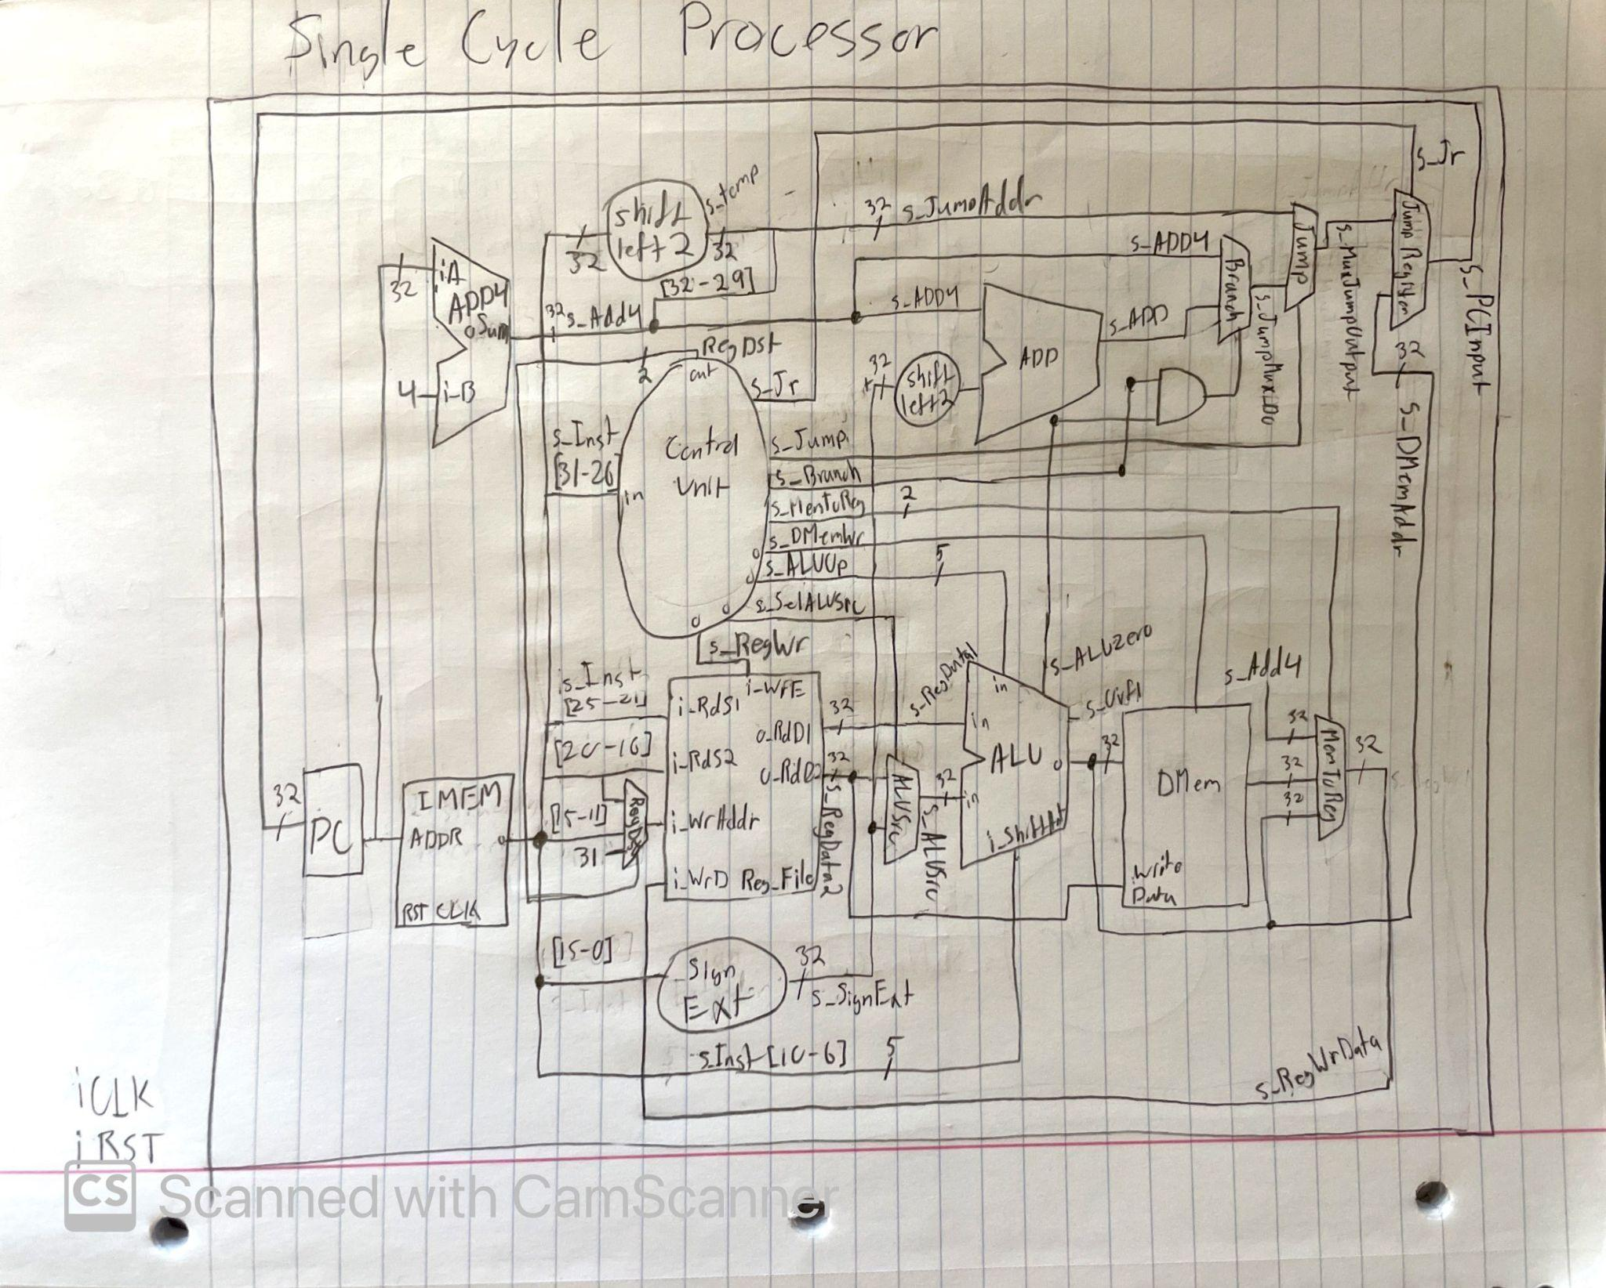

**[Part 2 (a.i)]** Spreadsheet detailing the list of *M* instructions supported by our project alongside their binary opcodes and funct fields, if applicable. There is a separate column for each binary bit. Inside this spreadsheet, there is a column for the *N* control signals needed for our datapath implementation. The end result being an *N*\**M* table where each row corresponds to the output of the control logic module for a given instruction.  
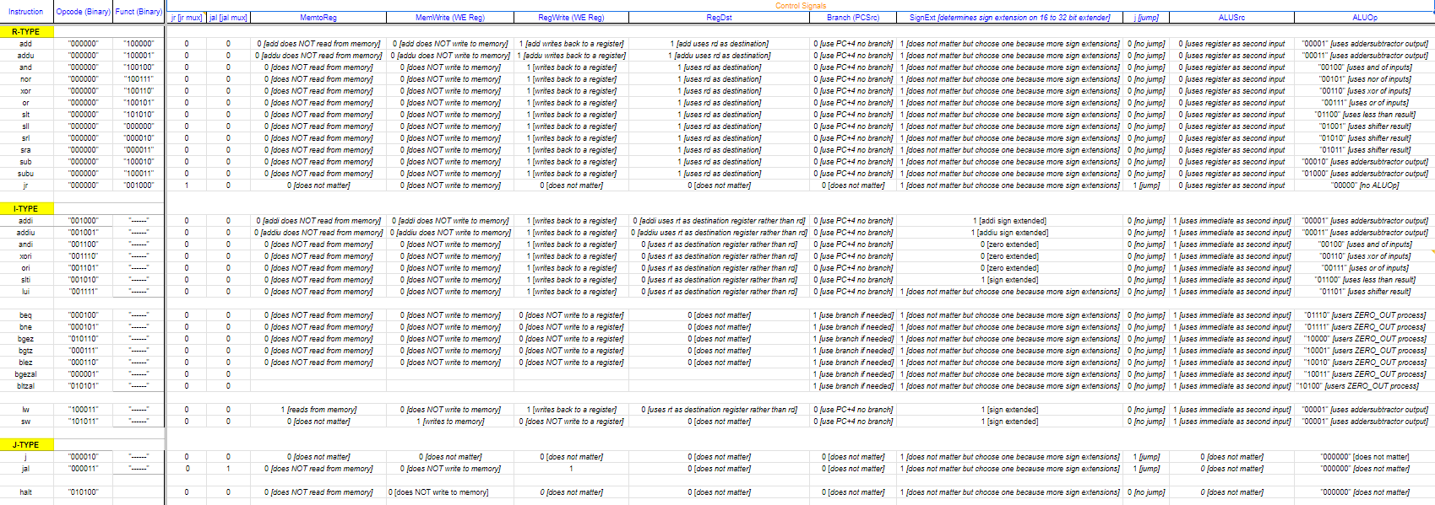

**[Part 2 (a.ii)]** Testbench output for testing the control logic module. Output of the testbench matches the expected control signals from problem 1(a).

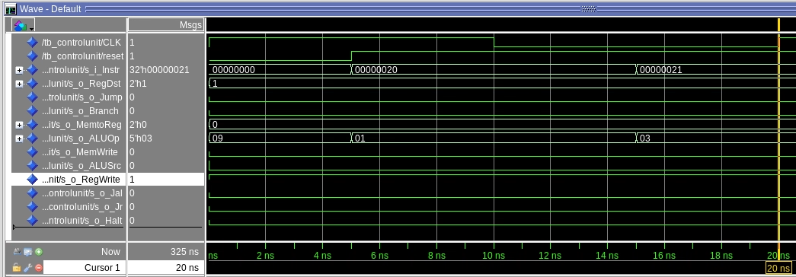

With an instruction of 0x0, the control unit determines that the desired instruction is sll and therefore sets the ALUOp code to 0x9. The following instruction’s value is 0x20 which translates opcode 0x1 which corresponds to an addi instruction. Accompanying signals such as o_Jump and o_Branch are set to the appropriate values for these two instructions, that being zero. Note that the “instruction” of our control unit consists of the Opcode concatenated with the function code for ease of determining the appropriate instruction.

**[Part 2 (b.i)]** Below is a description of what control flow possibilities our instruction fetch logic supports as a function of the different control flow-related instructions we implemented.

Control flow possibilities include jump and branch instructions such as j and beq. Our control unit uses select-when statements that analyze parts of the instruction to determine control signals for o_Branch, o_Jump, and if necessary o_ALUOp. For example, the jump instruction will set the o_ALUSrc mux to 1, o_Jump to 1, and set the remaining outputs to 0.

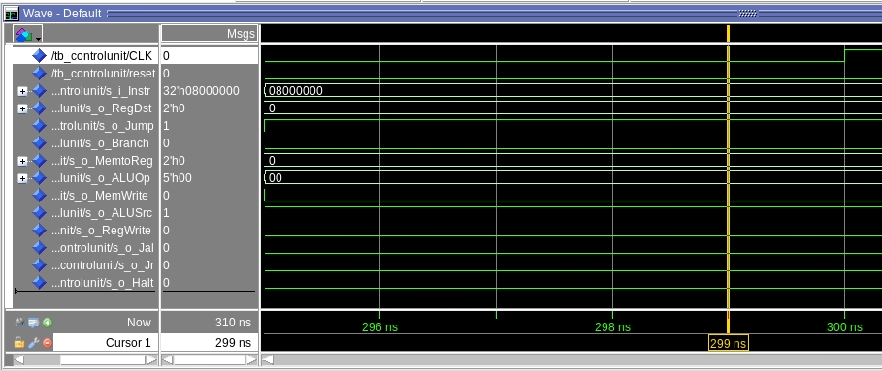

**[Part 2 (b.ii)]** Schematic for the instruction fetch logic and other datapath modifications needed for our control flow instructions.

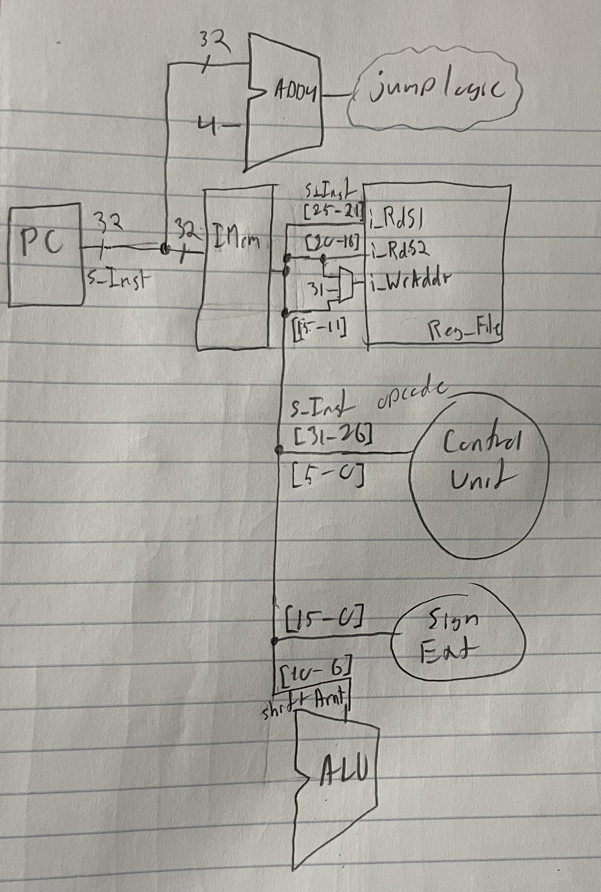

**[Part 2 (b.iii)]** Image of QuestaSim test output of for our design and description of how the execution of the control flow possibilities corresponds to the QuestaSim waveforms.

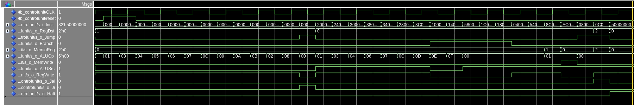

When fed an Opcode-Function instruction, the control unit analyzes each portion of the instruction and selects each output individually based upon the instruction. This is done with with-select statements and since each output is associated with its own with-select statement, these instructions must consider all outcomes which makes the select when statement appealing to use and fairly straightforward to implement without the need of process statements.

**[Part 2 (c.i.1)]** Brief describe of the difference between logical (srl) and arithmetic (sra) shifts and why MIPS does not have a sla instruction?

srl or sll are both logical shifts, meaning, they do not care about the sign of the number they are shifting. sra on the other hand does care about the sign of the number it is shifting. So, in srl, the bits added from the shift will be 0s. In sra, the bits added will ones when bit 31 is a one and zeros when bit 31 is a zero.  
  
The reason there is not a sla instruction is because bit 0 does not affect the sign of the number, so shifting arithmetically would not pose any help other than to add a value to the number you’re shifting.

**[Part 2 (c.i.2)]** Description of how our VHDL code implements both arithmetic and logical shifting operations.

In our VHDL code, we used a process statement with if else statements to select what type of shift to perform based on a shift type and shift direction input to the shifter. Once the type of shift and the direction of the shift was selected via the if statements, we then used the built in shift_right and shift_left functions, specifying a logical or arithmetic shift by using the built in signed() function. The amount the value was shifted was specified by the shift amount input to the shifter.

**[Part 2 (c.i.3)]** Brief explanation of our right barrel shifter’s support of left shifting operations.

Our barrel shifter is implemented in a way that it already supports left shifting operations. It can technically perform sll, srl, sla, and sra.

**[Part 2 (c.i.4)]** Description of how the execution of the different shifting operations correspond to the QuestaSim waveform output.

Above shows the output from the shifter test bench. s_ShiftType chooses between logical (0) and arithmetic (1) shifts, s_LeftRight chooses between a left (0) and right (1) shift, and s_ShiftAmt controls the shift amount.   
  
As you can see, when sll is performed (Cycle 1) the value x”A” is shifted left by x“A” with zeros filling in the lower bits. Likewise, when srl is performed (Cycle 2) the input value is shifted left by x”2” it fills in the upper bits with zeros, despite the most significant bit being a “1”.   
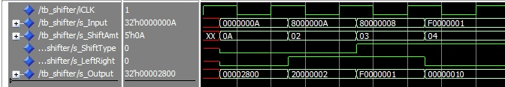

The next two cycles, sra (Cycle 3) and sla (Cycle 4), are executed correctly as well. When executing sra, it fills in hte most significant bits with ones, and when executing sla, it shifts the correct amount and fills the bottom bits with zeros, as expected.

**[Part 2 (c.ii.1)]** Description of our design approach, including resources we used to choose and implement our design and some of our design decisions.

When choosing how to design the shifter, we chose to use a process statement and use the build in VHDL shift_right(), shift_left(), signed(), and unsigned() functions. This made it very easy to implement the shifter because we were able to merely choose what operation to do using a few if statements with i_ShiftType and i_LeftRight as the conditionals. Although process statements were not recommended, when testing it, it worked just fine, so we proceeded with using it.

**[Part 2 (c.ii.2)]** Description of how the execution of different operations correspond to the QuestaSim waveform output.

As explained above, the testbench execute the sll, srl, sra, and sla operations in order. each operation corresponds to a new clock cycle, with one full clock cycle being 20ns long. Input values are assigned 1/4th of the way into the full clock cycle for waveform clarity.

**[Part 2 (c.iii)]** Simplified, high-level schematic for the 32-bit ALU.

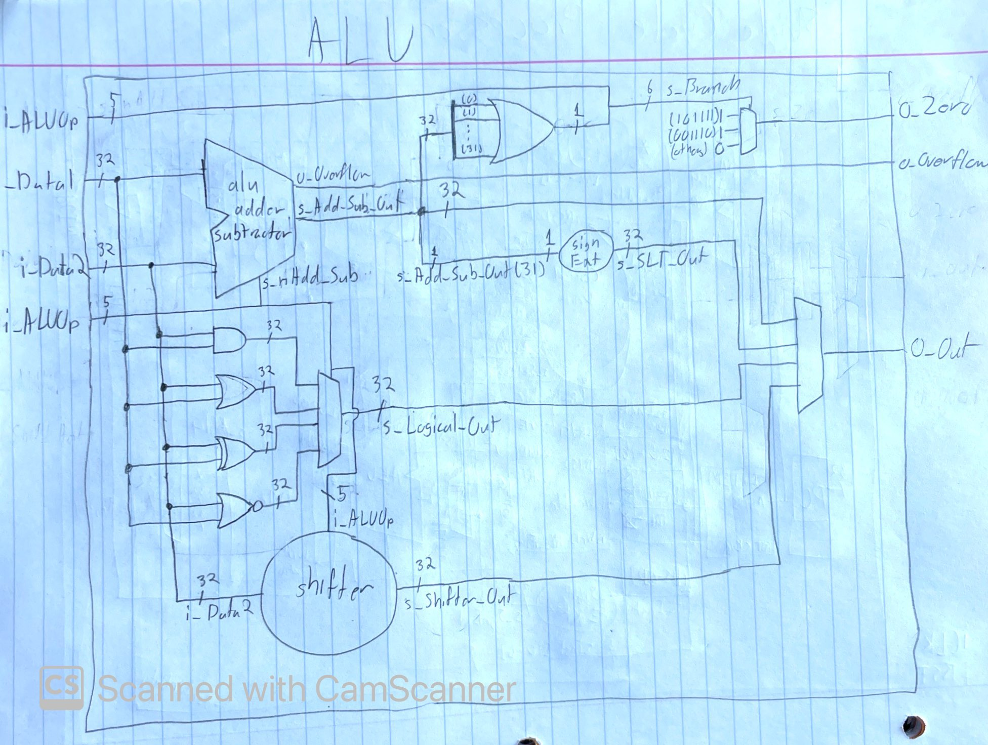

Overflow is calculated by XORing bit 31 of the alu_addersubtractor with the final carry out bit of the alu_addersubtractor output.   
Zero is calculated by checking if the alu_addersubtractor output is all zeros using a with select statement.  
Set on less than is implemented by checking if bit 31 of the alu_addersubtractor output is a 1 (aka if the result of input A minus input B was negative) using a with select statement. If bit 31 *was* 1, then it sets the output to 1.

**[Part 2 (c.v)]** Description of how the execution of different operations corresponds to QuestaSim waveform output.

The basic design philosophy of the ALU is similar to the Control unit but rather than using an Op-Function code signal to determine its outputs, the ALU primarily relies on the ALUOp value to determine what it will do.

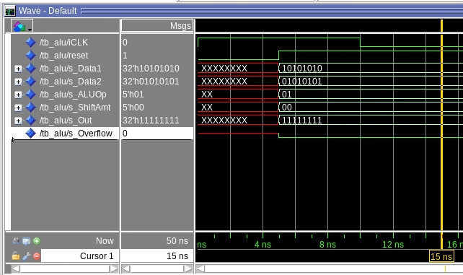

With an ALUOp of 0x01, the ALU determines that the instruction is to add the data inputs together. The ShiftAmt signal is not required for this specific instruction to function. The correct output of an add instruction should be 11111111.

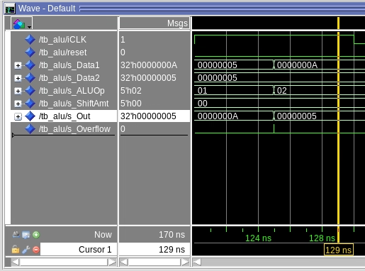

With an ALUOp of 0x02, the ALU determines that the instruction is to subtract data2 from data1. Again, the shift amount is not relevant for this instruction to work.

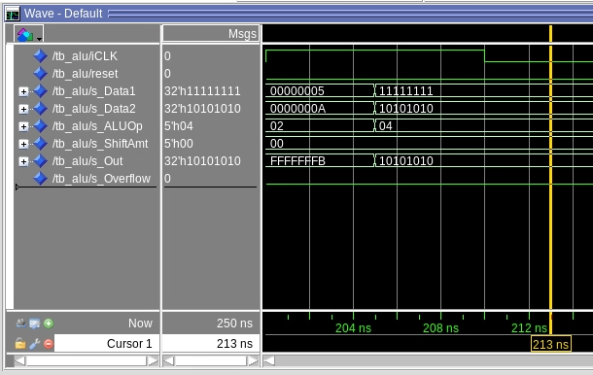

With an ALUOp of 0x04, the ALU determines that the instruction is to ANDi the values of data1 and data2, the ALU’s implementation uses a behavioral AND command to determine the output. Note that the process is similar for an AND instruction but is assumed that one of the data inputs has an immediate value and the other from a register.

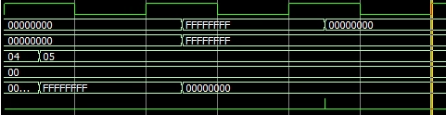

With an ALUOp of 0x05, the ALU determines that the instruction is to NOR the values of data 1 and data 2, the ALU’s implementation uses a behavioral NOR command to determine the output.

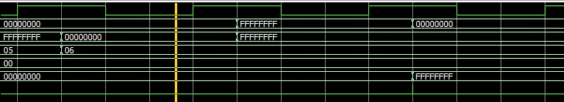

With an ALUOp of 0x06, the ALU determines that the instruction is to XOR the values of data1 and data2, the ALU’s implementation uses a behavioral XOR command to determine the output. Note that the process is similar for an XORi instruction but is assumed that one of the data inputs has an immediate value and the other from a register.

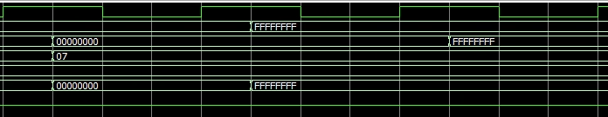

With an ALUOp of 0x07, the ALU determines that the instruction is to OR the values of data1 and data2, the ALU’s implementation uses a behavioral OR command to determine the output. Note that the process is similar for an ORi instruction but is assumed that one of the data inputs has an immediate value and the other from a register.

**[Part 2 (c.viii)]** Justification for why our test plan was comprehensive, including waveforms that demonstrate our test programs functioning.

Our tests consist of the following instructions: add, addi, sub, subi, and, andi, nor, xor, xori, or, ori

These tests demonstrate that correct values can be derived from the inputs of the ALU given these instructions. The instructions called are both R and I type instructions and demonstrates that the selectc-when logic blocks are not conflicting with each other and work with varying instruction sets.

**[Part 3]** QuestaSim output for each of the following tests, along with discussion of result correctness.

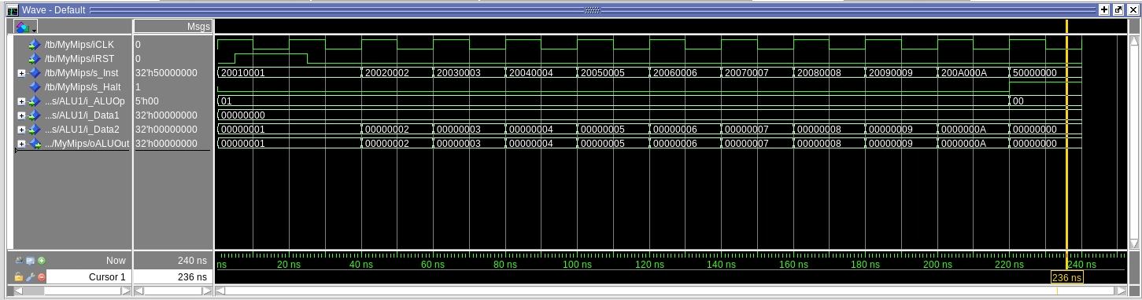

The above test consists of a sequence of addi instructions. The first cycle instruction is fed to the Control Unit and is broken down into a new internal signal consisting of the OpCode and the Function code. Since the OpCode portion of the instruction is 1000, the appropriate output signals are set for the various muxes and an ALUOp code of “00001” is forwarded to the ALU indicating to it to use the “addersubtractor” module. Since the instruction remains the same throughout the test, the Control unit does not change its outputs so the purpose of these series of tests really boils down to the reliability of the addersubtractor module.

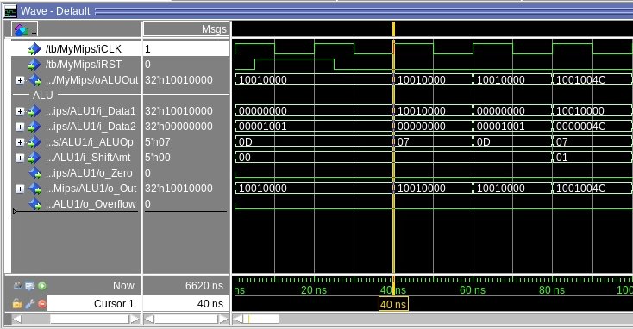

The above “fibonacci” test encounters an error with an jal instruction at MARS instruction number 132 but otherwise the tests work as expected. The first instruction (Beyond the reset cycle) is an “lui” instruction into MIPS register 1. The ALU output shows that the value 0x1001 is correctly loaded into the upper half of the register file as 0x10010000. The following instruction is an “ori” instruction that compares the zero register with the value in register 1. The output is similar to the input due to the logic of ori between zero and said input.

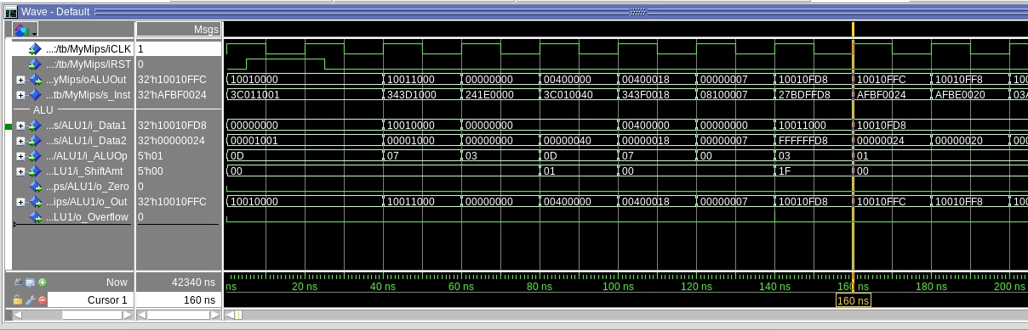

Test “grendel.s” utilizes sw commands throughout its process which is first executed 160 ns into the simulation. The instruction indicates that register 29’s (offset of 36) value is to be stored into memory register 31.

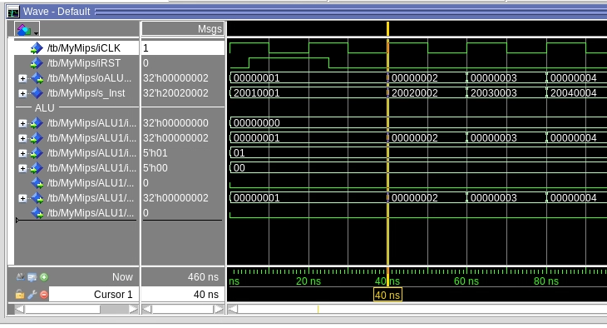

Test “lab3Seq.s” contains of many addi, sub, and add instructions which all have been used in previous instruction tests successively.

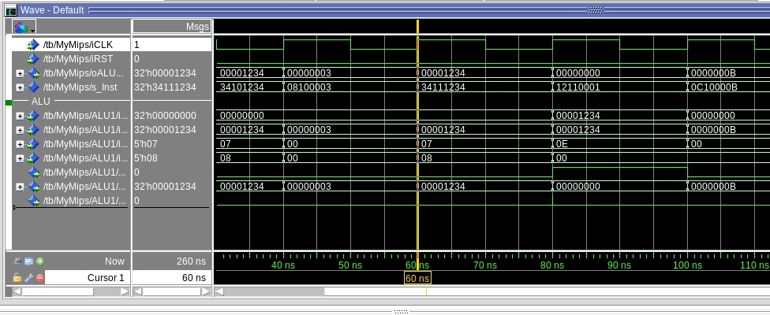

Test “simplebranch.s” uses many j, jal, and jr instructions. The j instruction writes the target address to the PC using MUXes, jal saves the next instruction to register 31 then jumps to the defined instruction, and jr jumps to an address that is stored within a specific register.

**[Part 4]** Report of maximum frequency our processor can run at and its critical path, highlighted in red in the schematic below. Brief mention of what components we would focus on to improve the frequency in the future.

The critical path is highlighted in red below. Improving the ALU’s branch logic performance would be our priority. Other components such as the AND gate and register files would likely be too difficult or impractical to improve further. Our frequency of the processor was about 23.1 MHz

